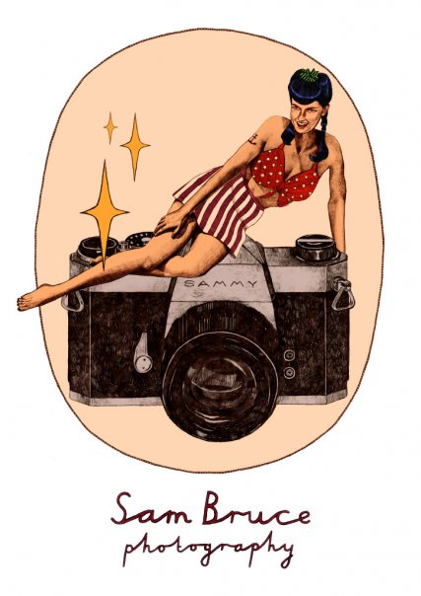
Sam Bruce Photography 2015

Event Price List

Sam Bruce is a wedding, documentary and portrait photographer based in Essex offering artistic wedding photography and contemporary lifestyle portraits.

Her aim is to give the Utmost professional service, making sure that every moment of your special day is captured, and priceless memories are remembered. Capturing the atmosphere and emotions that made your day so
wonderful that you can treasure forever.
Her style of photography is light and colourful with a dramatic twist with a combination of classic, informal and reportage coverage.

For standard event photography coverage Prices start from £250.00 for more enquiries please email
completed form and requirements of booking at sambrucephotography@yahoo.co.uk.

Date Of Event : Time Of Event:

Event Organiser

Name: Telephone:

Event Address: Mobile:

Email:

Postal

Address: Number of
(For sending Guests:
Proofs)

Event Occasion?:

Additonal Questions:
- What time and where would you like me to start & finsh?
……………………………………………………………………………………………………………………

- Any special requirements?
…………………………………………………………………………………………………………………………….

Sam Bruce Photography Booking Terms and Conditions

1. A Non-Refundable Deposit of £100.00 is required to secure booking.

2.Sam Bruce Photography takes every care with responsibility that comes photography being reliant and sufficient. However in the unlikely event of total photographic failure, sickness or injury or any situation beyond control, the client is entitled to a full refund of money paid and will not affect your statutory rights.

3. In the event of rain, snow or any other weather condition, the photographic session may be subject to change and will not take any responsibility to disappointment.

4. The photographer cannot guarantee of any specific located photographs, backgrounds and group arrangements.

5. The photographer is not responsible of any lack of coverage during the event if not instructed.

6. Any events outside certain areas the client is responsible for accommodation, food cost and travel.

7. All photographs taken at the event are protected by the Photographer under the British and International Copyright Laws and remain the property of the photography unless the payment for the services rendered was made in full by the Client proper to the production of the photographs where therefore the copyright ownership will be handed over to the client.

8.The photographer reserves the right to use any event photography for promotional and display purposes.

9.The Photographs will take a 7-10 working days from event date to be edited and finalised before a proof CD is handed over to you. Prints can take 1-2 weeks and if you have ordered a master CD they will be received with the photographs. The photo books can take 2-3 weeks. Every effort will be made to complete them as soon as possible.

10. The photographer cannot be held responsible for change of product as the manufacturer may discontinue certain page colours etc.

FULL NAME:………………………………………………………………………….
SIGNED:……………………………………………………………………………….
DATE:………./…………./……………..

Sam Bruce Photography 2014
Sambrucephotography@yahoo.co.uk

